Broderick Higby & Spencer Holloway

Java 112

8/27/2015

Java Applet Project

2 #33: If you want to change the eyes from circles to ovals, you would change the height value from 20 to 10 making both the height and width equivalent.

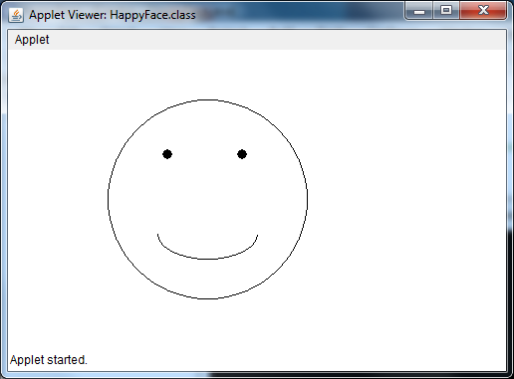

2. #34 If you wanted the face to frown you would change the starting point in the DrawArc method from 180 to 0

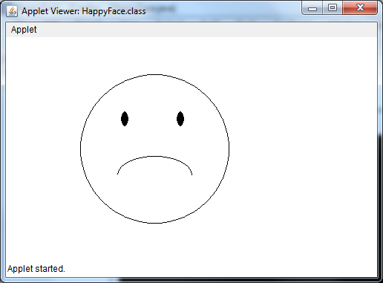

3.

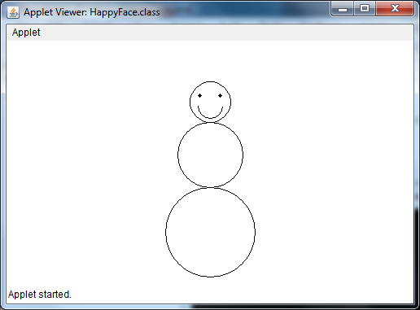

4.

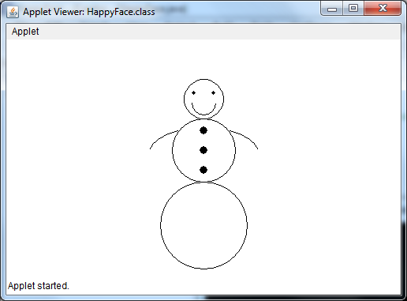

7. #21: If you were to change the order in which you write the drawing commands, it would alter the features one would see. Normally, you would want the largest piece in the background and add the smaller features later. In the case of the question, the mouth, since declared first, would be covered by the face.

#22: In this case, the face is coded twice. In doing so, the original color of the yellow face and the mouth will be covered by the new black face.